Walthall County School District



English Learner (EL) Plan

2025 - 2026

Walthall County School District

English Learner (EL) Plan

**Purpose**

The purpose of the English Learner (EL) Plan is to outline the Walthall County School District procedures will follow to ensure that all non-English speaking students are provided a free appropriate public education and any additional services required to attain proficiency in the English language.

**Enrollment**

Every public school in the United States is required to provide a free and equitable education to all school age children who live within the boundaries of the local educational agency (LEA), regardless of immigration status. Several laws protect the rights of ELs and their families, particularly during the enrollment process. These protections are provided because many EL students' levels of transiency and lack of English proficiency make them a particularly vulnerable population.

LEAs and their public schools must enroll all students regardless of their or their parents' or guardians' current or perceived citizenship or immigration status.

When enrolling students, LEAs may not request information from students or their parents or guardians in order to deny access to public schools on the basis of race, color, or national origin.

Walthall County School District requires the following document when enrolling a student unless otherwise indicated as optional.

* Birth Certificate
* Immunization Record Form 121
* Social Security Number (Optional if Parent does not wish to provide)
* 2 Proofs of Residency (Information as to acceptable proofs can be obtained at the school prior to enrollment.)
* Completed registration packet to include Home Language Survey

Parent(s) or Legal Guardian(s) must be present when rolling up the child. No child will be enrolled if a parent(s) or legal guardian(s) is not present at the time of enrollment unless prohibited by the McKinley-Vento Homeless Assistance Act.

**Identification of English Learner[1]**

The Home Language Survey (HLS) [2]must be completed for each new student registering for enrollment in a school in Mississippi. The HLS is used to identify students whose first language is not English. If there is a response on the HLS indicating a language other than English as the first language by the student or an individual in the home, then further assessment will be conducted to determine the student's English-language proficiency level.

English Language Proficiency Assessment ( ELPA21) is used to determine the level of English proficiency and to facilitate appropriate instructional and program placement decisions. Students identified by the HLS during registration whose first language is a language other than English at the beginning of the school year must be assessed for English-language proficiency within 30 calendar days of initial day of enrollment. Students who register after the beginning of the school year and indicate on the home language survey that their first language is a language other than English must be assessed within 10 school days of enrollment.

NOTE: The English Language Proficiency Assessment (ELPA 21) assesses the proficiency of students in all four language domains (ie, speaking, listening, reading, and writing). Those administering and scoring the placement test must be one of the following: the District Test Coordinator or a certified teacher both of whom have been trained to administer the assessment.

The student's placement test report must be placed in their cumulative record along with the original copy of the home language survey.

EL students who leave the district for a district in another state or country must be retested prior to placement back in the EL service program. Testing timelines previously mentioned will apply to a student returning from another state or country.

Students who enroll in the district for the first time at the secondary level are assessed using the English Language Proficiency Assessment (ELPA21). However, careful consideration is to be given to the student's course schedule to ensure the student has access to a high school diploma. Students are required to take the state assessments if the assessment is in a course they are currently enrolled in. Courses cannot be taken out of sequence if a sequence exists however, courses can be taken simultaneously. Example, English III cannot be taken before English I or II but English II and English III can be at the same time provided the student has successfully taken English I.

**Parent Notification**

Parents of a student who qualifies for services shall be sent notice of placement and services within thirty days of the start of the school year or within ten days for students eligible enrolling after the initial day of school. The notice may either be mailed to the parent or guardian or sent home with the student. The parent or guardian has the right to request a conference further explaining the ruling or the services that will be provided. The notification must include all of the statutorily-required elements, including the right to opt out

Any parent or guardian whose child is receiving or is eligible to receive EL services has the right to decline or opt his or her child out of any or all EL services. The district will provide guidance in a language parents or guardians can understand to ensure that they understand their child's rights, the range of EL services that their child could receive, and the benefits of such services to ensure that the parent or guardian's decision to opt out is informed and voluntary.

After ELs have been identified using the English Language Proficiency Assessment (ELPA21), the district must provide ELs with appropriate language assistance services and programs, commonly known as “EL services and programs.” The district has the flexibility to choose the EL services and programs that meet civil rights requirements and best meet the needs of their EL population.

**Language Service Plans[3]**

Each student identified as an English Learner (EL) must have a Language Service Plan per Mississippi Department of Education guidelines. Language service plans are updated annually until the student exits the EL program. The Student Evaluation Team (SET) must meet to develop the LSP at the beginning of each academic school year. The Student Evaluation Team is composed of current regular education teachers, English Learner teachers, Special Education Teachers if applicable, Administrators, Counselors, and Parents or Guardians. The team will meet quarterly to evaluate the student's progress and make necessary adjustments. A copy of the LSP must be provided to all teachers who work with the EL student.

**English Learner English Language Proficiency Assessment**

The Elementary and Secondary Act (ESEA) and the Every Student Succeeds Act (ESSA) requires that all students [4]identified as English Learners be assessed for English language proficiency on an annual basis.

The current approved English language assessment is the ELPA21 English Language Proficiency Assessment. The assessment is currently given in the month of March and the first part of April.

The ELPA21 covers the areas of speaking, listening, reading and writing.

Students taking this assessment may be provided reasonable accommodations allowed by the Mississippi Department of Education when taking this assessment. The *Mississippi Testing Accommodations Manual* outlines the accommodations available for students who have been identified as English Learners.

Scores from the ELPA21 are usually received during the month of June following the assessment. Score reports will be sent to parents or guardians at the beginning of the next school year. The reports will be given to parents or guardians when the student enrolls for the next school year. Copies of the score reports are placed in the student's cumulative folder. Reports for students who transfer to another school during the summer months are included with the record sent to the new school.

**Grading and Retention**

As students are working to learn English during the initial stages of language acquisition, it is a violation of their Civil Rights to retain them due to limited language proficiency. Schools must ensure that EL students are placed appropriately and can participate meaningfully and equally in educational programs as noted in Title VI of the Civil Rights Act of 1964 (Title VI) and the Equal Opportunities Act of 1974.

Walthall County School District will take steps to ensure that students are not retained solely because they are still in the early stages of learning English. Students who receive extensive language support and classroom accommodations must have this information noted on their report cards, and accommodations must be shared with the parents or guardians of the students to ensure they have an understanding of true academic performance in English language proficiency.

Students may be retained if all of the following criteria have been met.

* Documentation of interventions that show that English is not a barrier.
* Meeting with Parents or Guardians to discuss retention.
* Signed agreement by Parents or Guardians.

**Students Exiting the Program and Monitoring Exited Students**

Students may exit the EL program by achieving the following scores on the English Language Proficiency Assessment. (These are the only criteria allowed for a student to exit the program.)

* Overall Proficiency Score – Level 4 or 5 and
* Reading Proficiency Score – Level 4 or 5 and
* Writing Proficiency Score – Level 4 or 5.

An EL student with a disability can be “exited” from EL status when he or she no longer meets the definition of an EL. This occurs when the student meets the State's definition of “proficient” in English. The student's EL status cannot be removed based solely on the fact the student has an IEP.

Students who have achieved the proficiency levels above and exited the program must be monitored for a period of four academic years. Monitoring must be conducted and documented every 9 weeks, with a SET team reviewing monitored students' grades, assessments and other related data. Monitored students who are not achieving at a satisfactory level may be provided Tier II interventions if deemed necessary to provide the additional support to help them be successful on the state standards.

The district will retest using the English Language Proficiency Assessment (ELPA21) to see if the student needs to be offered additional language assistance services if an exited EL is not progressing academically as expected and monitoring suggests a persistent language need. Students will be retested after Tier II interventions have been documented as not assisting the student in achieving at a satisfactory level. In no case should re-testing of an exited student's ELP be prohibited. If the student re-enters EL services, however, the LEA is required to document the reasons why, as well as obtain the parent's consent prior to reentry.

**English Learner Services and Instructional Support**

Students identified as English Learners must be provided with appropriate English Learner language assistance services. The district will provide English Learner students with access to the content of the Mississippi College and Career Readiness Standards and other services, including special education, gifted education, and extracurricular programs, as needed.

ELs will have meaningful access to the core curriculum, such as mathematics, science, social studies and language arts, while learning English. While the district's EL program focuses in part on language acquisition, both EL teachers and academic teachers should work together to ensure that students are mastering the academic language needed to be successful.

The Multi-Tiered System of Supports (MTSS) is a framework for effective team-based problem solving that is data informed, evidence-based, and flexible enough to meet the academic and behavioral needs of all students. With MTSS, schools identify struggling students, monitor student progress, provide evidence-based interventions, and adjust the intensity and nature of those interventions depending on a student's responsiveness. Schools also identify students with learning disabilities, language barriers, and/or other disabilities. English Learner students with learning disabilities can also be identified using this methodology.

**English Learner Programs, Staffing and Resources**

Walthall County School District currently utilizes an immersion program to provide services to students identified as English Learners. Students receive additional instruction during times that do not interfere with regular classroom instruction. English Learner students will receive a minimum of thirty minutes of additional instruction in learning English per week.

Walthall County School District utilities classroom teachers, to provide support for students identified as an English Learner.

Classroom teachers will be provided the necessary resources to conduct the program.

**Training**

Teachers of English Learner students will have opportunities to receive appropriate training in order to build effectiveness of the program. Regular classroom teachers will be encouraged to obtain the endorsement for English as Second Language by taking the appropriate coursework or Praxis assessment.

Regular education teachers are encouraged to attend training provided by the Mississippi Department of Education and other reputable sources.

Teachers who have attended training for strategies to teach EL students will be expected to share these strategies with other teachers in the district.

**Teacher Recruitment**

Walthall County School District makes every effort to recruit, hire and retain teachers in every area that are licensed and have the necessary skills to instruct students on the challenging Mississippi College and Career Ready Standards.

The District will provide training for teachers who do not meet the licensing requirements for the English Learner program.

**Program Evaluation**

Walthall County School District will evaluate the English Learner Program on an annual basis. The following data sources will be incorporated within the evaluation of the program.

* Scores on state and local assessments
* Scores on the English Language Proficiency Assessment
* Retention Rates
* Exit Rates
* Graduation Rates
* Participation rates in gifted and advanced courses
* Enrollment rates in prekindergarten and other programs
* Enrollment rates in special education and related services
* Attendance
* Participation rates in extracurricular programs
* Discipline incidents and suspension rates
* Results or parent and family, student teacher and stakeholder surveys

Other data may be included in the evaluation if data from one or more of the sources above is not available.

**Parent and Family Engagement**

The Walthall County School District has a legal obligation to communicate meaningfully with Limited English Proficient parents and families and to adequately notify them of information about any program, service or activity called to the attention of non-LEP parents. Successfully provides communication LEP parents, guardians, and families with the school-related information they need to make informed decisions about, and be helpful participants in, their children's education. This may include, but is not be limited to, information about language assistance programs, special education and related services, Individualized Education Program (IEP) meetings, grievance procedures, notices of nondiscrimination, student discipline policies and procedures, registration and enrollment, report cards, requests for parent or guardian permission for student participation in district or school activities, parent-teacher conferences, parent handbooks, gifted programs, and magnet and charter schools.

The Walthall County School District will provide information to LEP parents and guardians with documents in a language they can understand when necessary. Interpreters that are proficient in the required language will be obtained upon request by the parents or guardians.

The Walthall County School District will collaborate with outside agencies to assist parents or guardians in the acquisition of English language skills in order to assist them with the communication between the school and parents or guardians.

**Appendix A**



**Appendix B Example of a Home Language Survey**

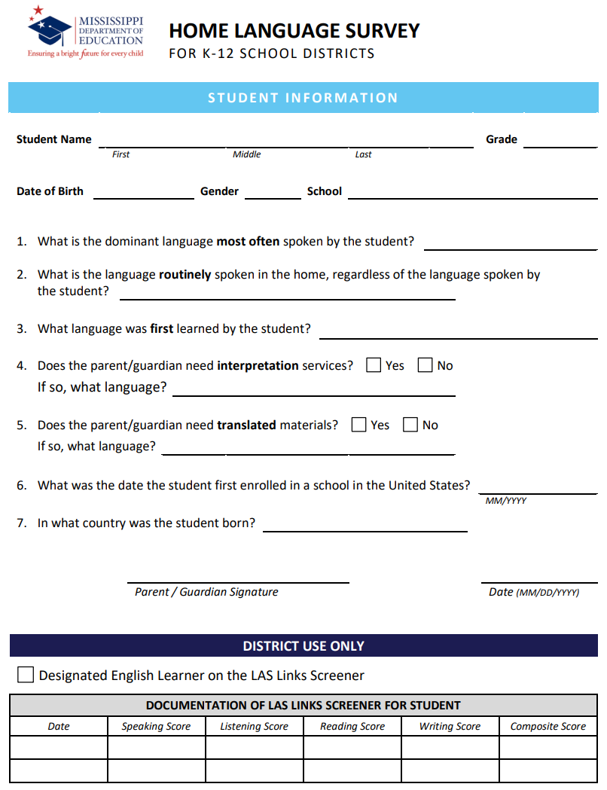

1. Flow Chart found in Appendix A
2. See Appendix B for Home Language Survey
3. See MTSS Packet on the Mississippi Department of Education website for Language Service Plan
4. All students include students whose parents have opted out of EL program/services.