Walthall County School District
English Learner (EL)
Plan
2023-2024

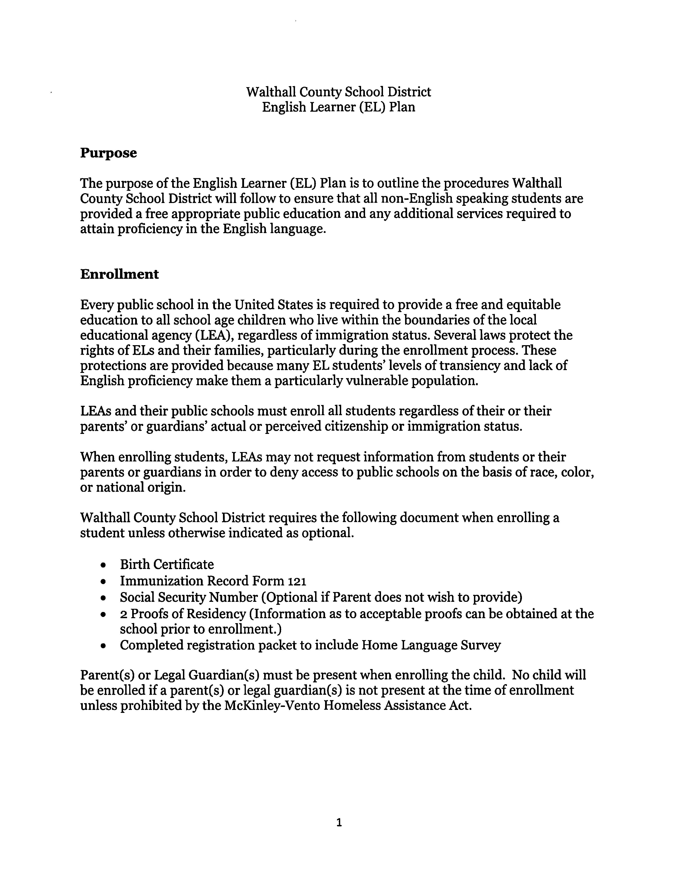

Identification of English Learner
The Home Language Survey (HLS) must be completed for each new student registering for enrollment in a school in Mississippi. The HLS is used to identify students whose first language is not English. If there is a response on the HLS indicating a language other than English as the first language by the student or an individual in the home, then further assessment will be conducted to determine the student's English-language proficiency level.
The LAS Links Placement Test is to be used to determine the level of English proficiency and to facilitate appropriate instructional and program placement decisions. Students identified by the HLS during registration whose first language is a language other than English at the beginning of the school year must be assessed for English-language proficiency within 30 calendar days of initial day of enrollment. Students who register after the beginning of the school year and indicate on the home language survey that their first language is a language other than English must be assessed within 10 school days of enrollment.
NOTE: The English Language Proficiency Test (ELPT) assesses the proficiency of students in all four language domains (i.e., speaking, listening, reading, and writing). Those administering and scoring the placement test must be one of the following, the District Test Coordinator or a certified teacher both of which have been trained to administer the assessment.
The student's placement test report must be placed in their cumulative record along with the original copy of the home language survey.
EL students who leave the district for a district in another state or country must be retested prior to placement back in the EL service program. Testing timelines previously mentioned will apply to a student returning from another state or country.
Students who enroll in the district for the first time at the secondary level are assessed using the LAS Link Placement assessment. However, careful consideration is to be given to the student's course schedule to ensure the student has access to a high school diploma. Students are required to take the state assessments if the assessment is in a course they are currently enrolled. Courses cannot be taken out of sequence if a sequence exits however, courses can be taken simultaneous. Example, English III cannot be taken before English I or II but English II and English III can be taken at the same time provided the student has successfully passed English I.
2

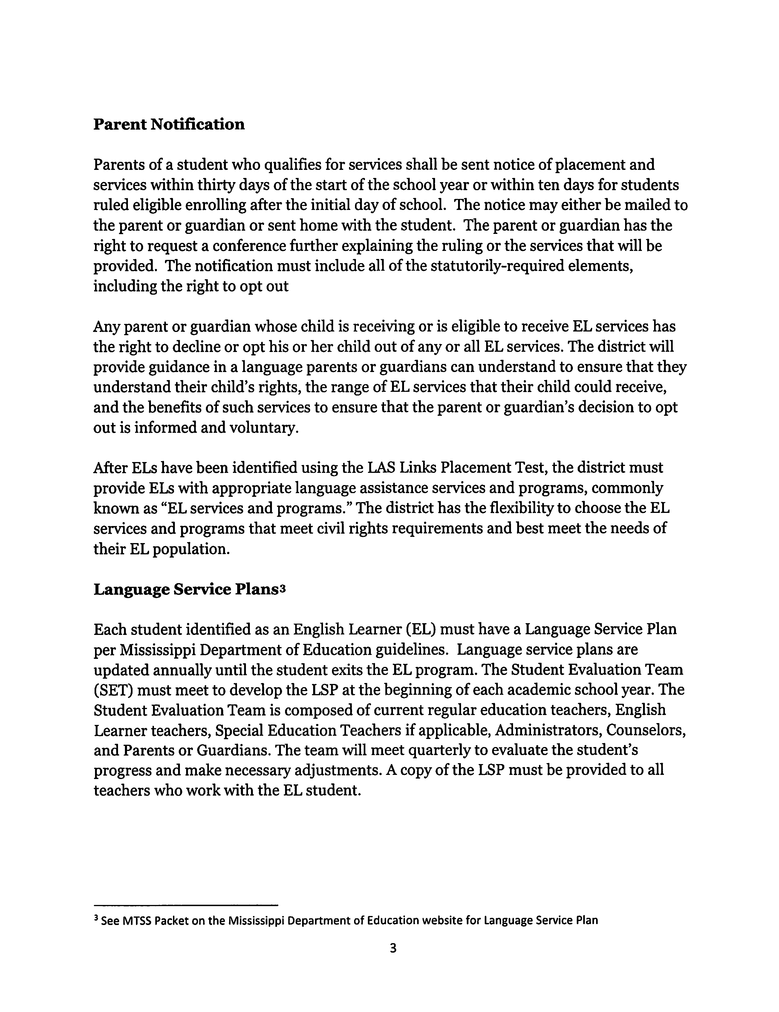

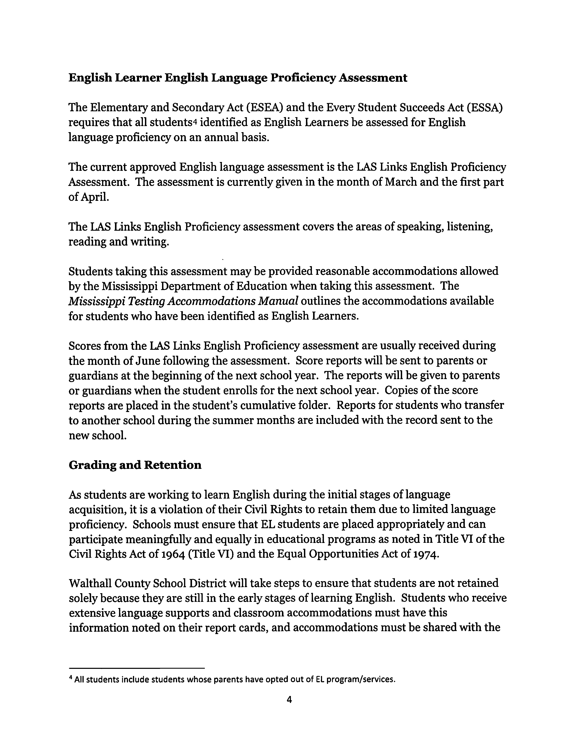

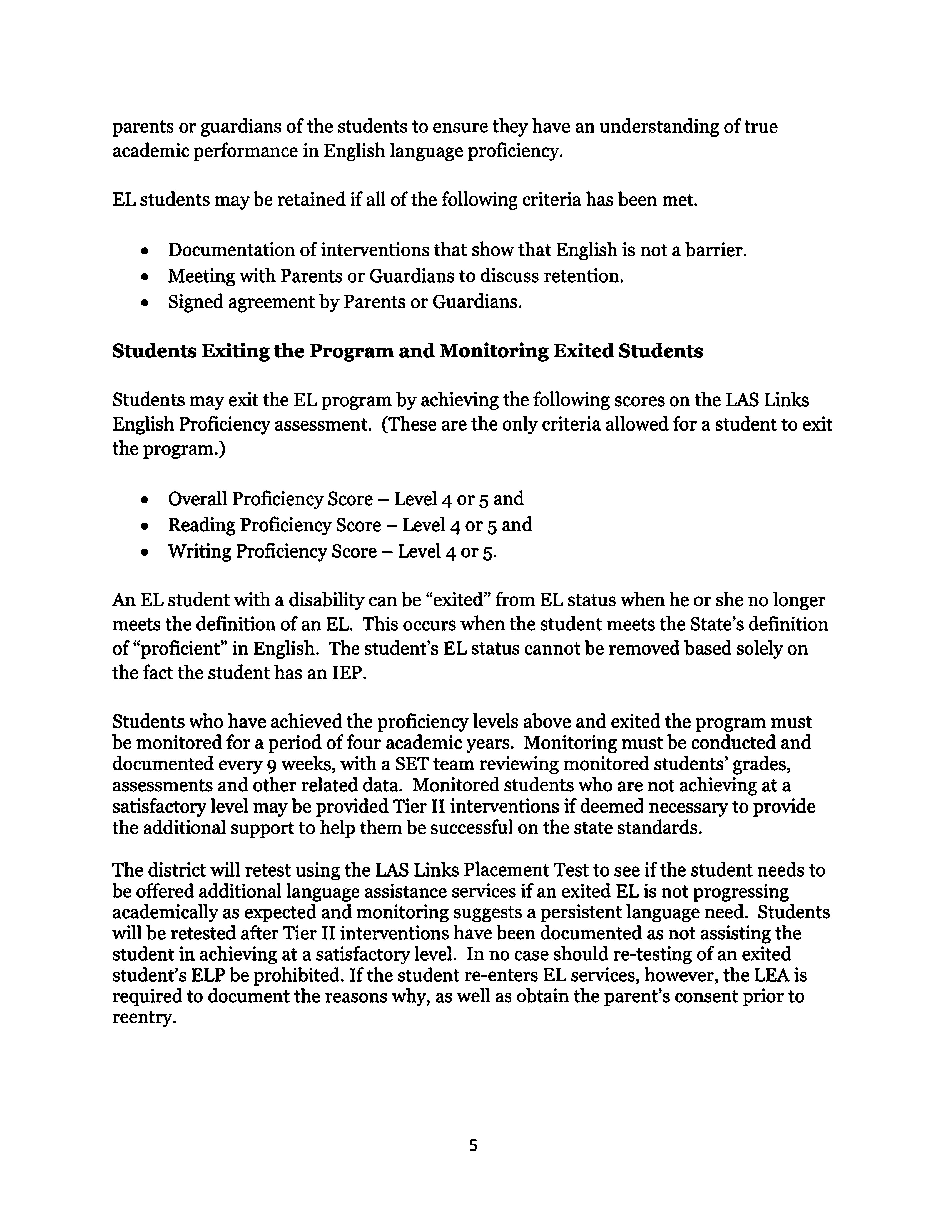

English Learner Services and Instructional Support
Students identified as English Learners must be provided with appropriate English Learner language assistance services. The district will provide English Learner students with access to the content of the Mississippi College and Career Readiness Standards and other services, including special education, gifted education, and extracurricular programs, as needed.
ELs will have meaningful access to the core curriculum, such as math, science, social studies and language arts, while learning English. While the district's EL program focuses in part on language acquisition, both EL teachers and academic teachers should work together to ensure that students are mastering the academic language needed to be successful.
The Multi-Tiered System of Supports (MTSS) is a framework for effective team-based problem solving that is data informed, evidence-based, and flexible enough to meet the academic and behavioral needs of all students. With MTSS, schools identify struggling students, monitor student progress, provide evidence-based interventions, and adjust the intensity and nature of those interventions depending on a student's responsiveness. Schools also identify students with learning disabilities, language barriers, and/ or other disabilities. English Learner students with learning disabilities can also be identified using this methodology.

English Learner Programs, Staffing and Resources
Walthall County School District currently utilizes an immersion program to provide services to the students identified as English Learners. Students receive additional instruction during times that do not interfere with regular classroom instruction. English Learner students will receive a minimum of thirty minutes of additional instruction in learning English per week.
Walthall County School District utilities classroom teachers, to provide support for students identified as an English Learner.
Classroom teachers will be provided the necessary resources to conduct the program.

Training
Teachers of English Learner students will have opportunities to receive appropriate training in order to build effectiveness of the program. Regular classroom teachers will be encouraged to obtain the endorsement for English as Second Language by taking the appropriate coursework or Praxis assessment.
Regular education teachers are encouraged to attend training provided by the Mississippi Department of Education and other reputable sources.
6
Teachers who have attended training for strategies to teach EL students will be expected to share these strategies with other teachers in the district.

Teacher Recruitment
Walthall County School District makes every effort to recruit, hire and retain teachers in every area that are licensed and have the necessary skills to instruct students on the challenging Mississippi College and Career Ready Standards.
The District will provide training for teachers that do not meet the licensing requirements for the English Learner program.

Program Evaluation
Walthall County School District will evaluate the English Learner Program on an annual basis. The following data sources will be incorporated within the evaluation of the program.
- Scores on state and local assessments
- Scores on the English Language Proficiency Assessment
- Rates of Retention
- Exit Rates
- Graduation Rates
- Participation rates in gifted and advanced courses
- Enrollment rates in prekindergarten and other programs
- Enrollment rates in special education and related services
- Attendance
- Participation rates in extracurricular programs
- Discipline incidents and suspension rates
- Results of parent and family, student teacher and stakeholder surveys
Other data may be included in the evaluation if data from one or more of the sources above is not available.

Parent and Family Engagement
The Walthall County School District has a legal obligation to communicate meaningfully with Limited English Proficient parents and families and to adequately notify them of
7

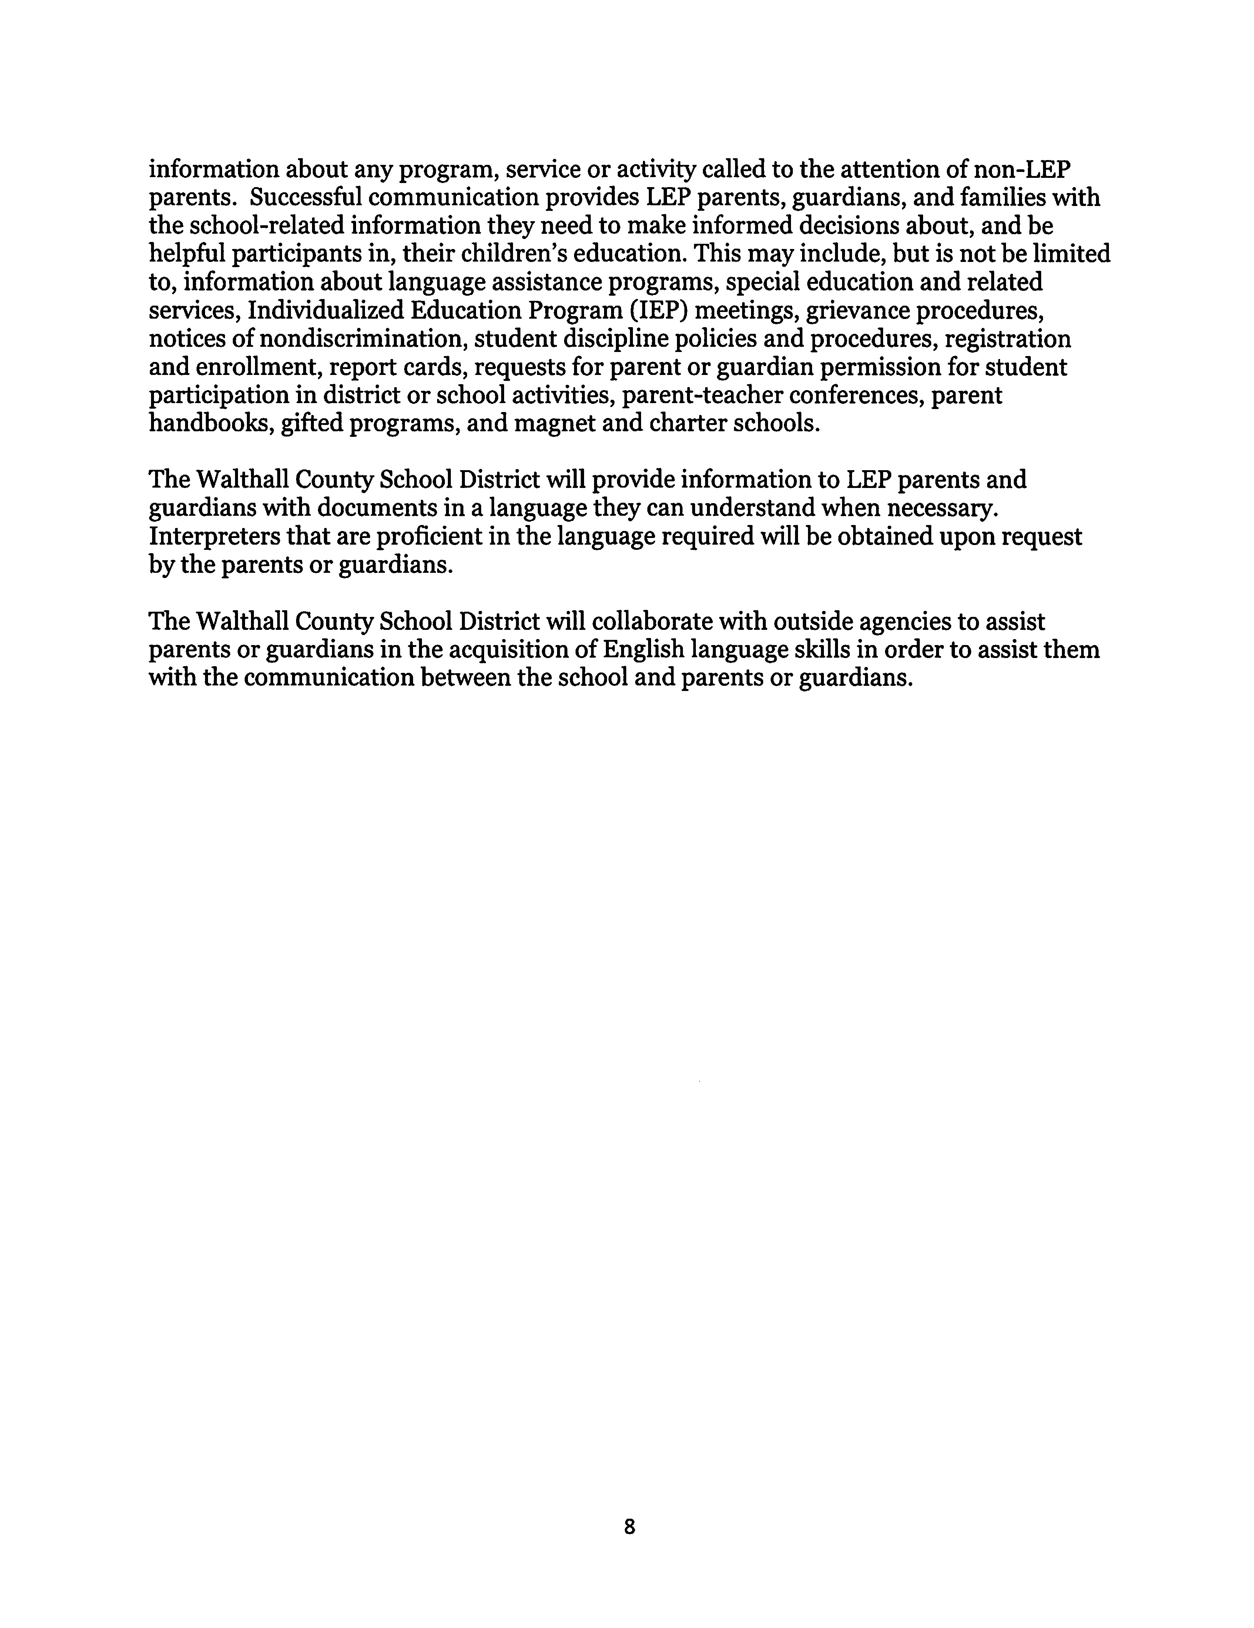

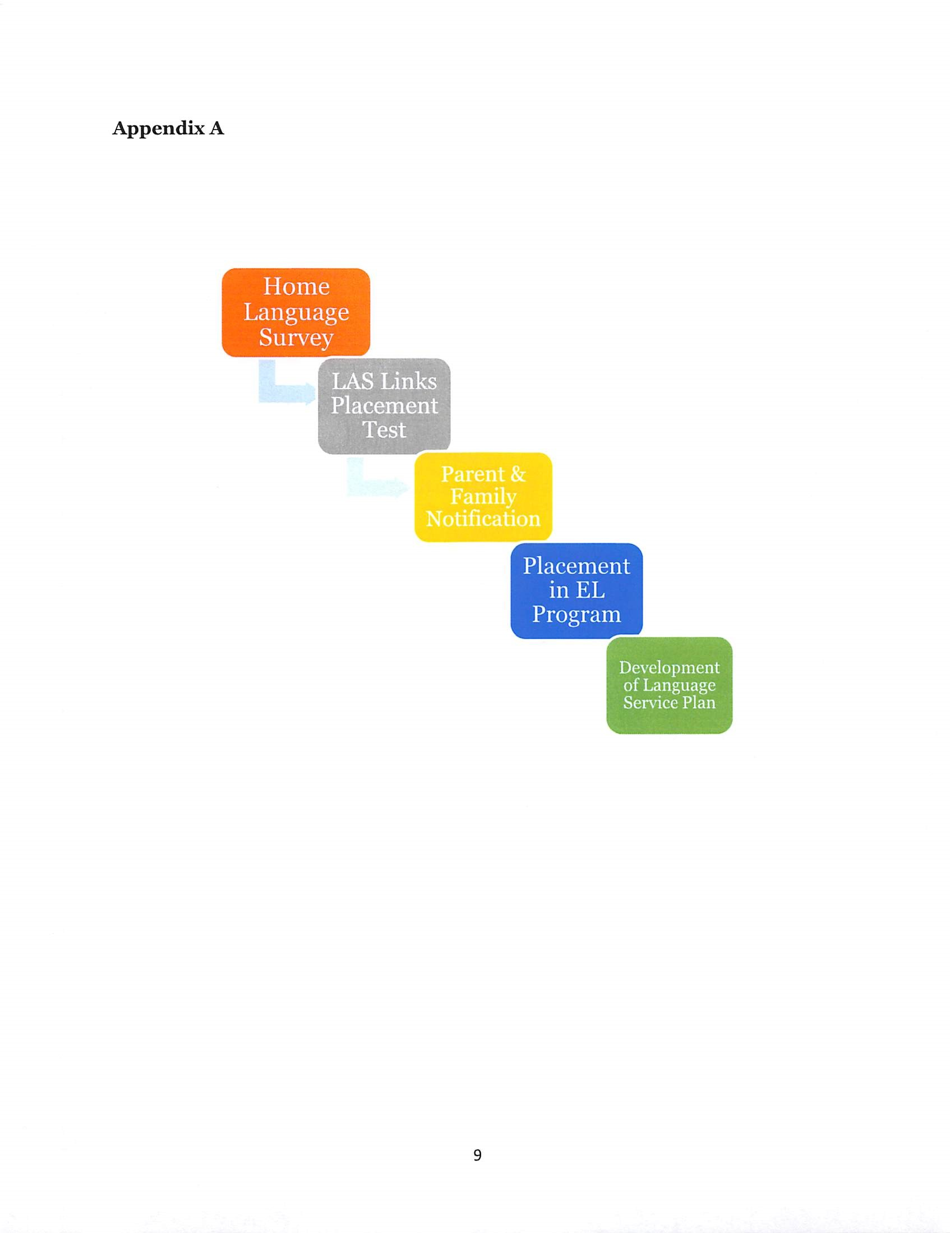

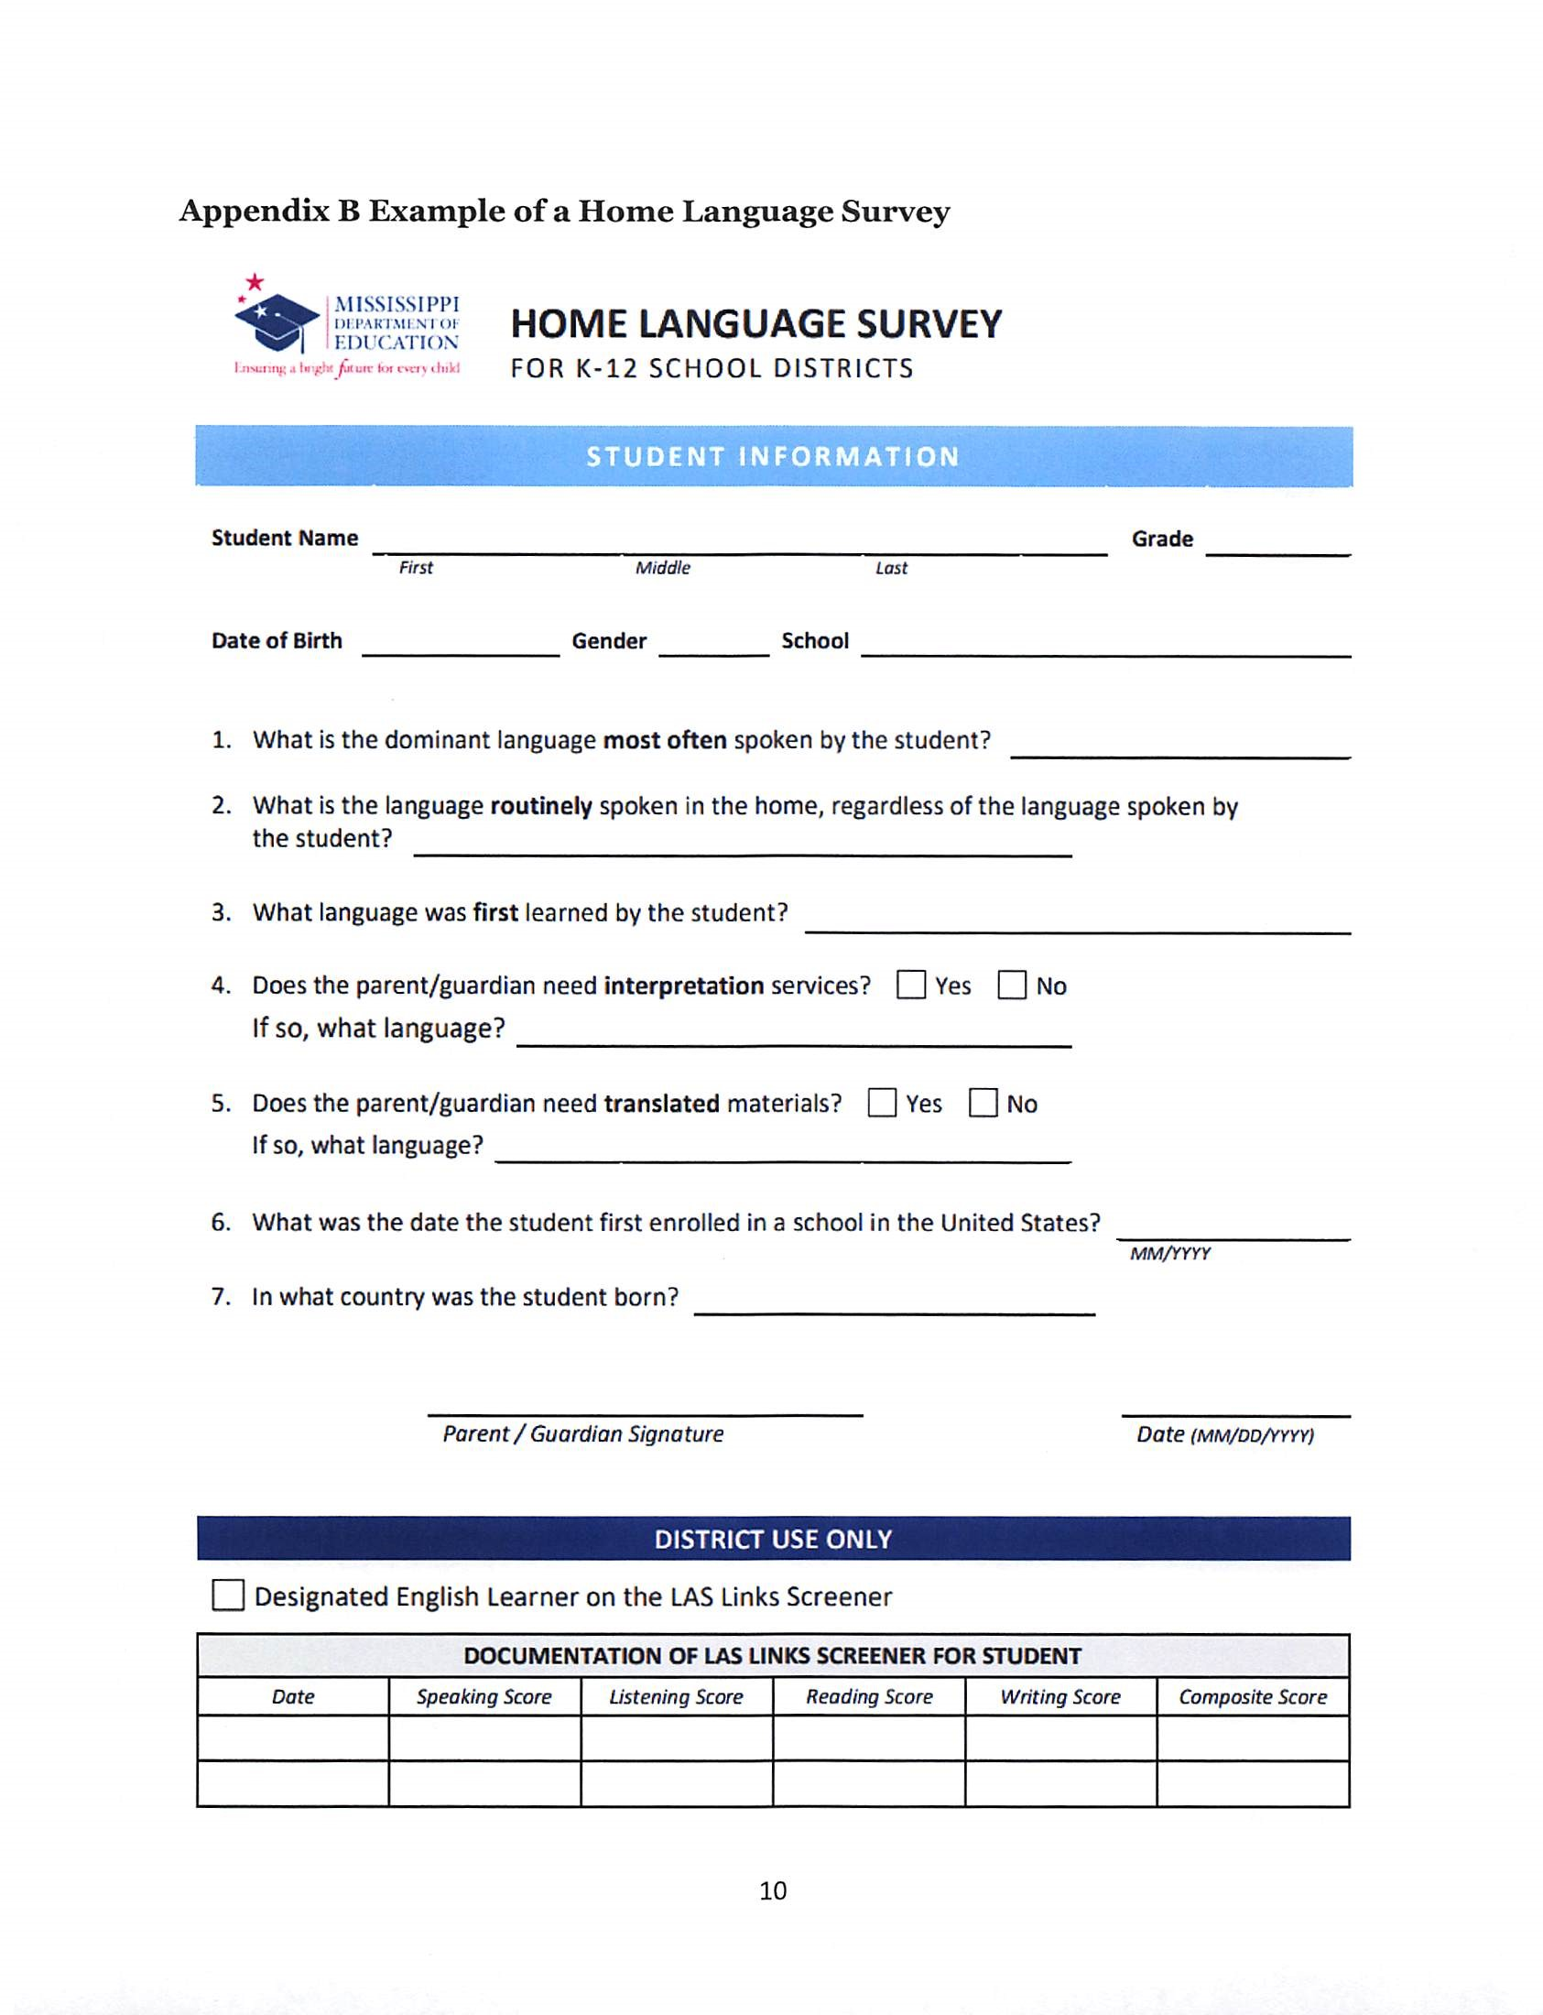

Flow Chart found in Appendix A
See Appendix B for Home Language Survey

